Councilor Report; Speeding in Great Barton

Speed Indicator Devices, SID, (VAS & Evolis)

The new Evolis has been on test for the last 12 weeks, initially on Mill Rd but has had significant testing (8 weeks) on the A143 at the Nook. It has received positive feedback from both locations and has been successful at reducing speeds when activated.
It was initially used in battery mode on Mill Rd, batteries needed changing every 7 days which was time consuming and meant it was not operating all of the time. It has a range of 1200 ft so was measuring car speeds in the 60 mph limit so the data collected was not useable. This device is larger than the VAS and post used on Mill Rd is too close to the road with a risk of a larger vehicle damaging the sign. The post is also too short to affix the Solar Panel in the correct position. Hence it is not practical to use this device on Mill Rd without a new, taller post being erected.
As a result an extensive trial was carried out at The Nook as the post is far enough away from the road & taller enough to locate the Solar Panel. The trial has been running for 77 days, 15 (2 separate weeks) of which were in Spy Mode giving an indication of baseline speeds equivalent to normal speeds when there is no SID. It was also recording incoming traffic (from Bury) where the SID was visible to traffic and in outgoing mode (towards Bury) but the speed is not seen by the driver. A summary of the traffic speeds is tabled below representing 300,000 vehicles coming from Bury and 231,000 vehicles going to Bury:-

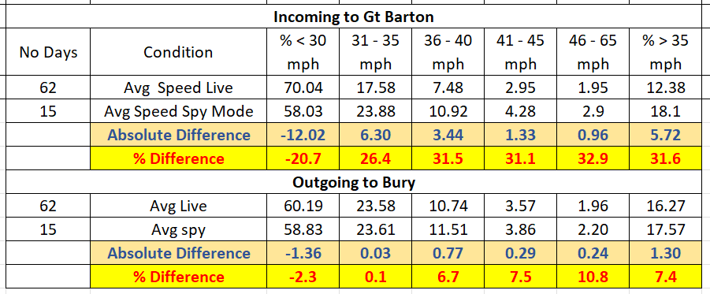

The difference from the baseline (Spy Mode) to Live Mode showed:-
1) An absolute increase of 12% of vehicles complying with the 30 mph speed limit or a relative improvement of 21% when compared to those already exceeding 30 mph.
2) As the police will not prosecute anyone unless they are travelling > 35 mph, our real target is probably to aim to get everybody to travel < 35 mph in the village. In this case there has been an absolute reduction of 5.7% or a relative one of 31%.
3) In fact there has been similar relative improvements across all speed ranges.
4) For outgoing vehicles there has been much smaller improvements. This is not unexpected as the drivers get no indication of their speed. The average speeds are very similar to the incoming vehicles in Spy Mode.
5) Examining the live weekly data (8 weeks) has shown that the improvements are sustained (30% vehicles > 30 mph) and drop back to normal when not operating (42% vehicles > 30 mph).
Although measurements have covered 531,000 vehicles, 530 vehicles were recoded at > 60 mph, a few vehicles between midnight and 5 am have been travelling between 80 – 90 mph.
Overall, the new Evolis has had a significant impact mainly because of the large & striking graphics, facile & quick downloading of data (< 2 mins by the roadside) & good statistics analysis. In Solar Mode, no support is needed although it is impractical to move the Solar Panel to a different location.
The VAS is easier to move between locations as there is no solar element to consider, however data download & analysis is much slower and difficult to carry out near the roadside. Although the display is less striking, I assume it is leading to a reduction in traffic speeding although I have yet to see that analysis due to a data download issue.

Proposal

We should purchase another Solar Evolis to create 2 permanent locations on the A143 at the Nook and Mill Road. The latest SCC Policy on SID’s requires then to be switched off for a minimum of 1 week (can switch to Spy Mode & still record data?). This will require a new post install on Mill Road. The VAS would then be used as our mobile SID between the other 6 locations.
Estimated cost are £2120 (ex. VAT) for Solar Evolis & £570 for SCC to install the post.

Speedwatch

Progress has been slow mainly down to police resource availability, paperwork has led to a several of the volunteers dropping out & the admin team have lost some of the paperwork. On the positive side, we have approval for 8 monitoring spots, 9 confirmed volunteers & we have advertised for more in the upcoming Newsletter. Start in October hopefully?
Evolis Data Analysis Examples

Average Speed by Day

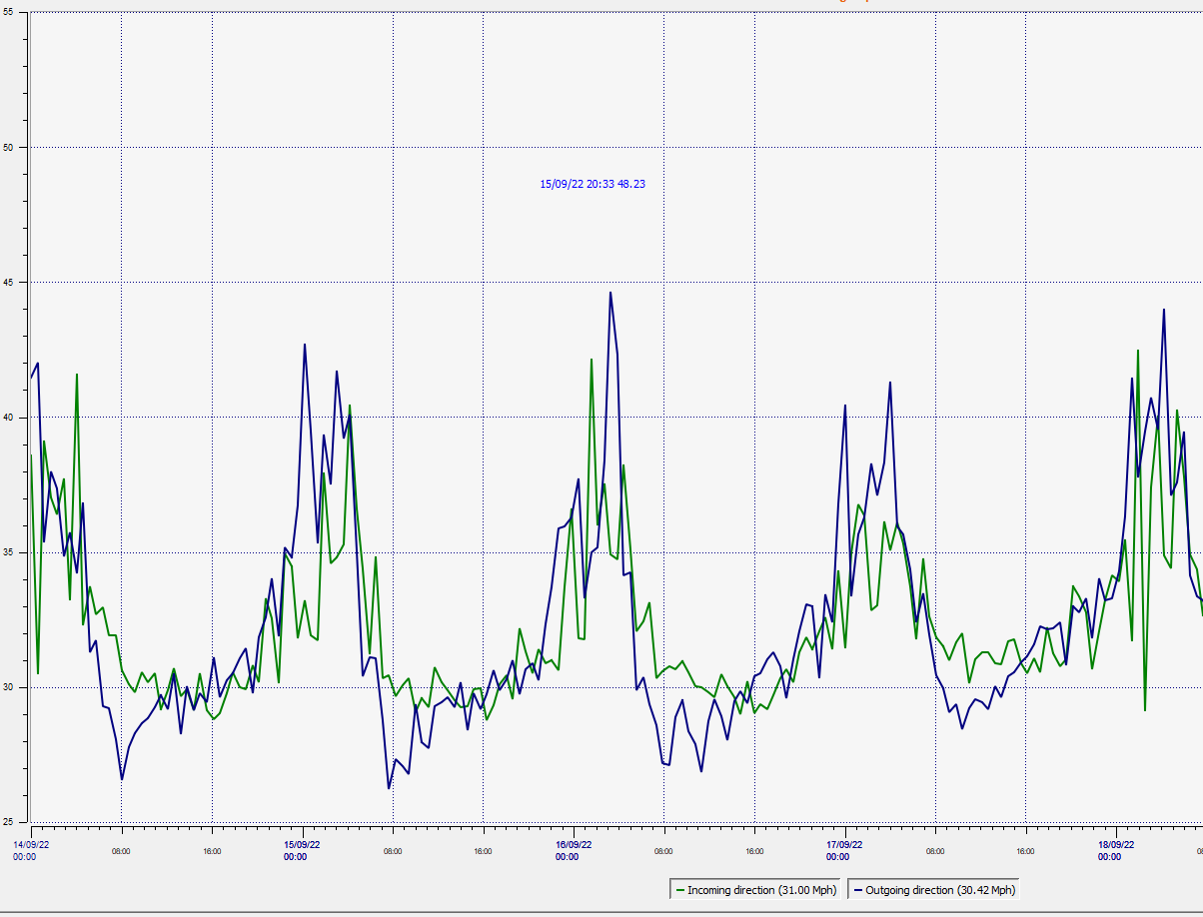

Distribution of Vehicle Speeds

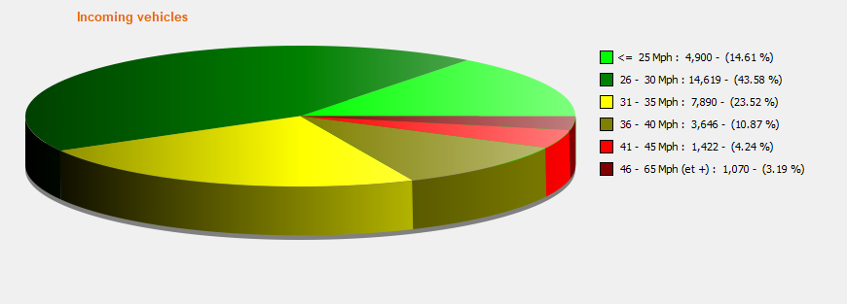
Number of Vehicles By Day (Incoming is green, outgoing is blue)

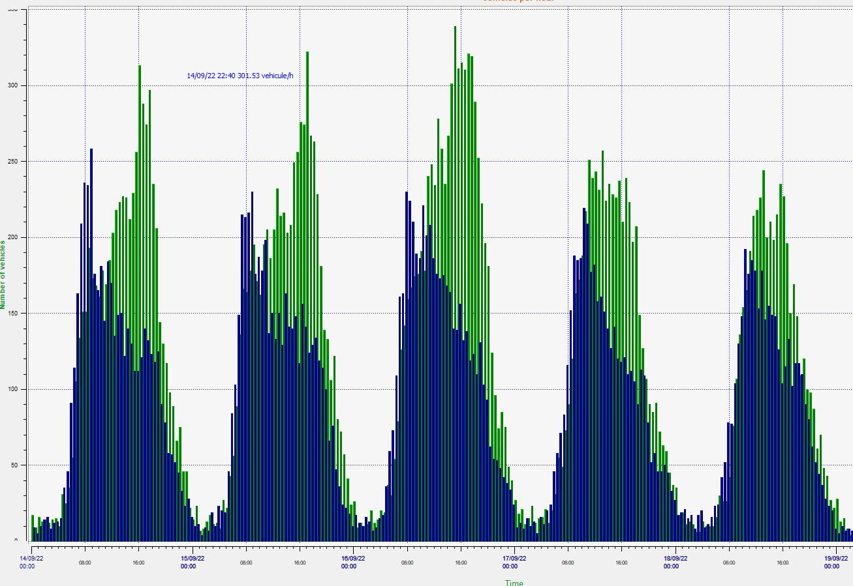

Maximum Vehicle Speeds

